GitHub Repo Link: https://github.com/fenilfinava/StudentHub/tree/main/Practical-5

1. Complete Registration Form
The Student Registration form contains Full Name, Email Address, Mobile Number, Gender (radio buttons), Course and Admission Year (dropdowns), Password, Confirm Password and a Terms & Conditions checkbox. Proper labels and HTML5 input types are used so the form is accessible and keyboard-friendly.
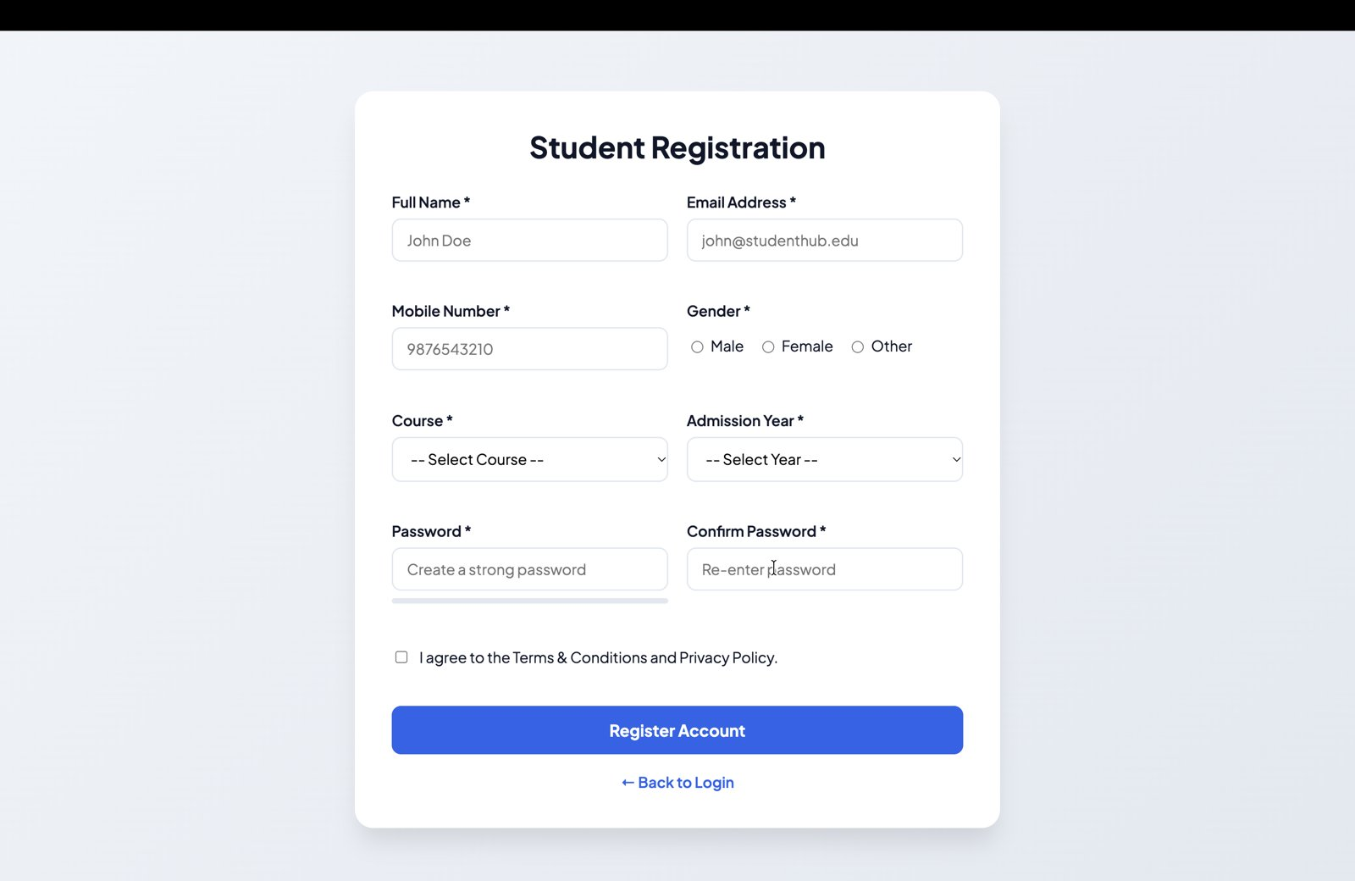
Figure 1: Complete registration form

2. Valid Input and Successful Validation
When all fields are filled correctly and the Terms are accepted, clicking "Register Account" passes all JavaScript validations and shows a success message.
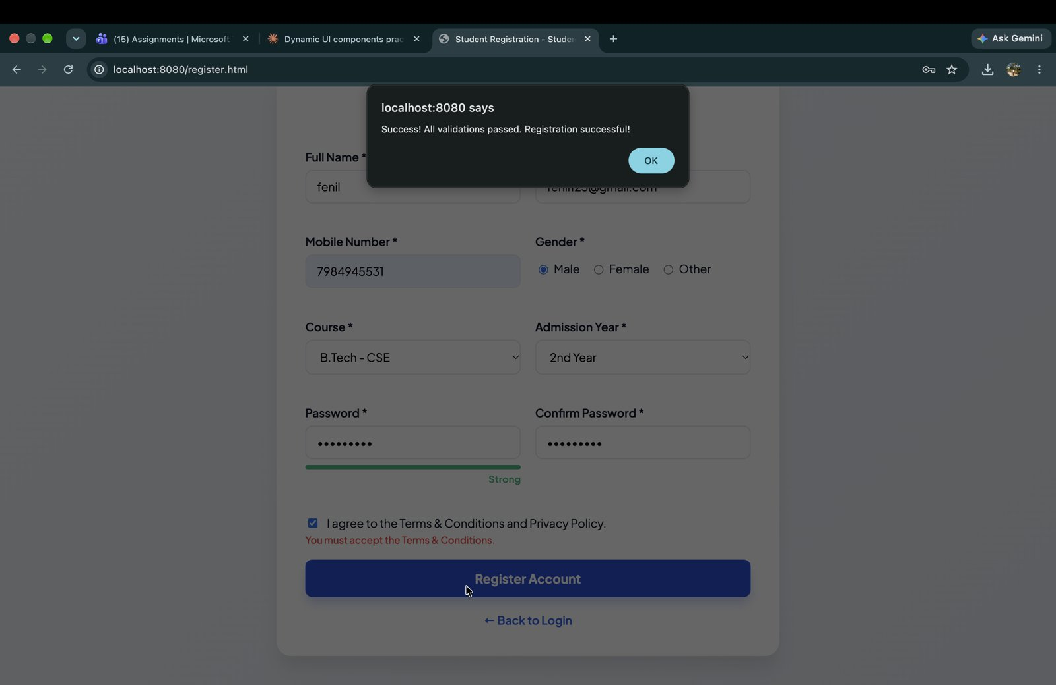
Figure 2: Valid input with "Registration successful!" message

3. Invalid Name / Email / Mobile Validation
Regular expressions are used to validate the fields. An invalid name (letters only, minimum 3 characters), an invalid email address and a mobile number that is not exactly 10 digits show error messages directly below the respective fields.
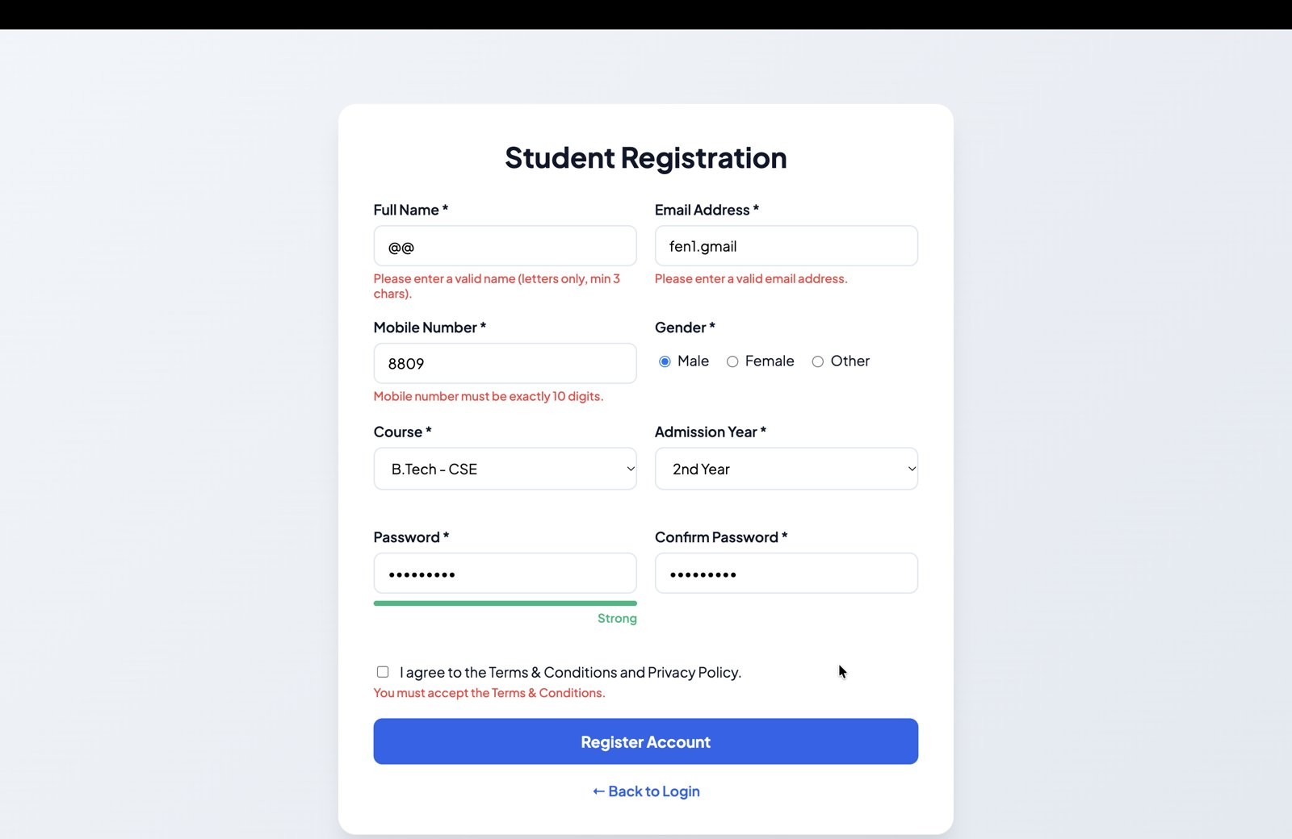
Figure 3: Error messages for invalid name, email and mobile number

4. Password & Confirm Password Validation
If the Confirm Password value does not match the Password, an error message is displayed below the Confirm Password field.
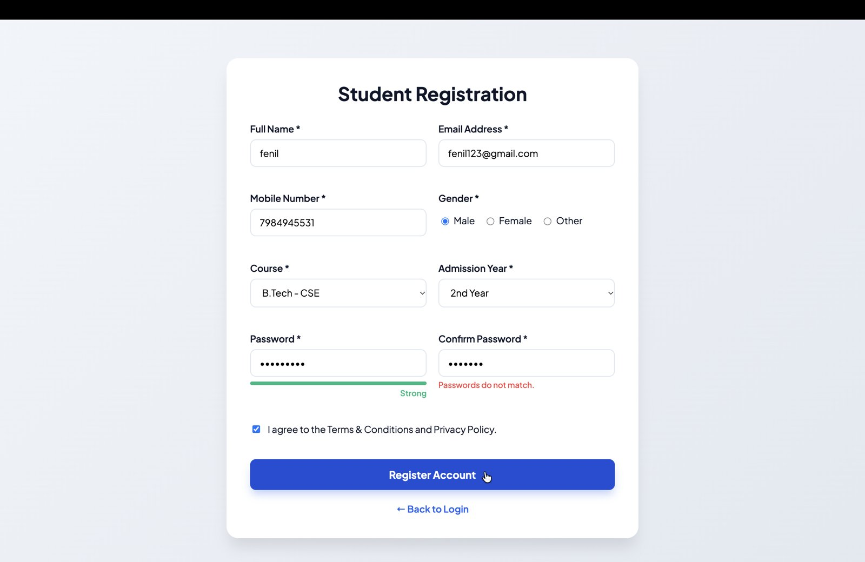
Figure 4: "Passwords do not match." error

5. Password Strength Indicator
A strength bar below the Password field updates while typing and shows Weak, Medium or Strong based on the password pattern (length, letters, numbers and special characters).
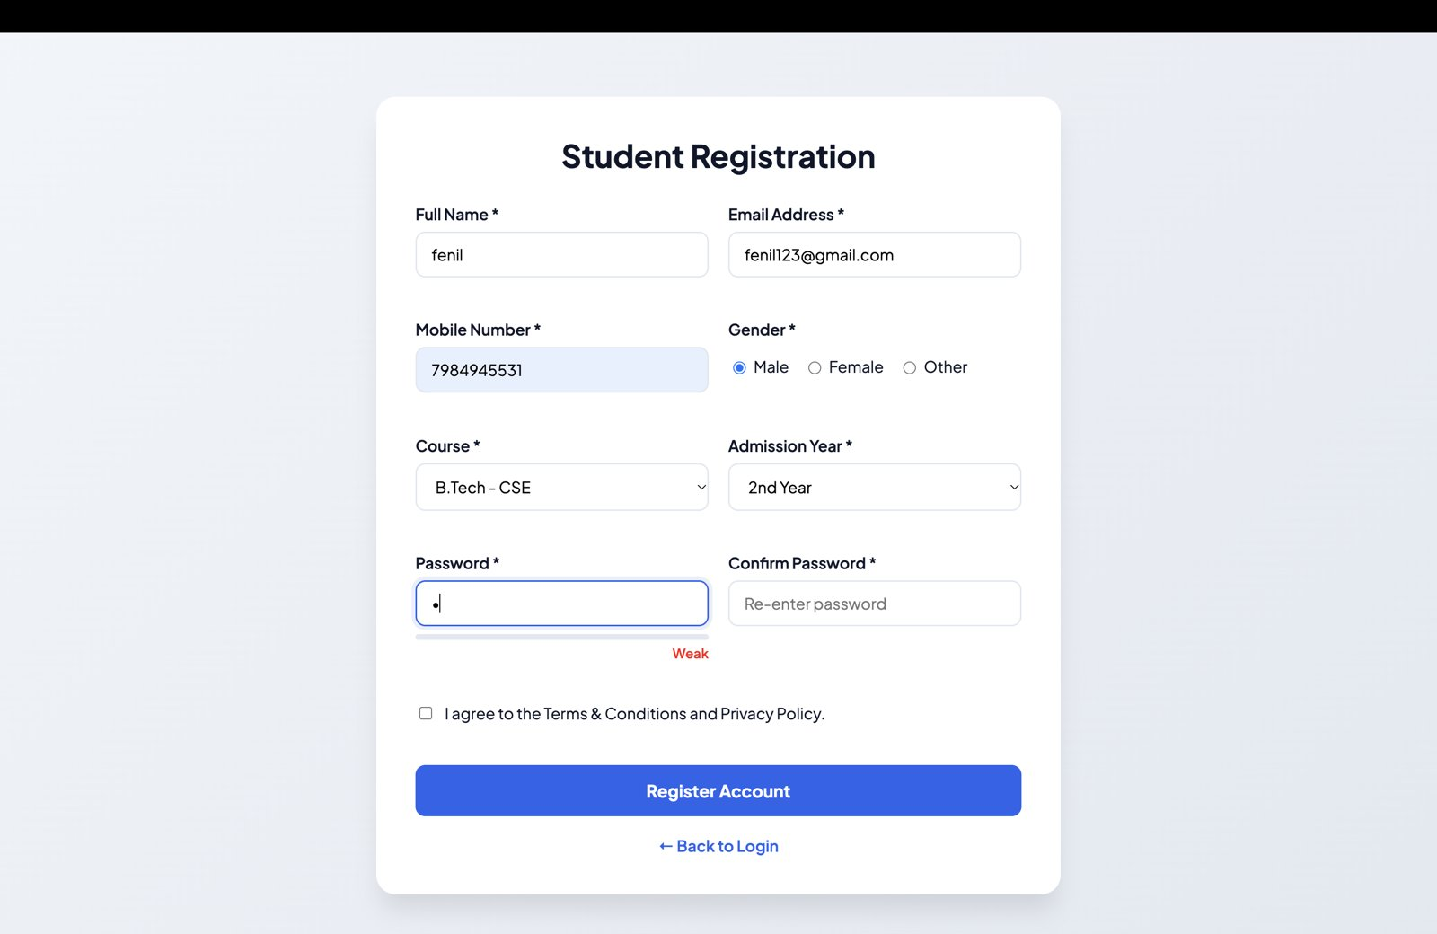
Figure 5: Weak password
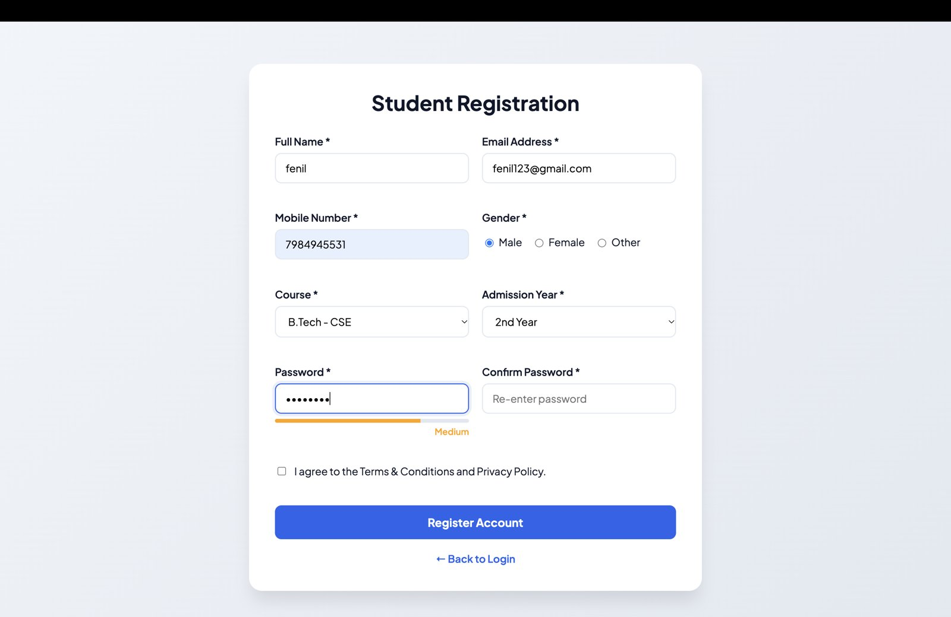
Figure 6: Medium password

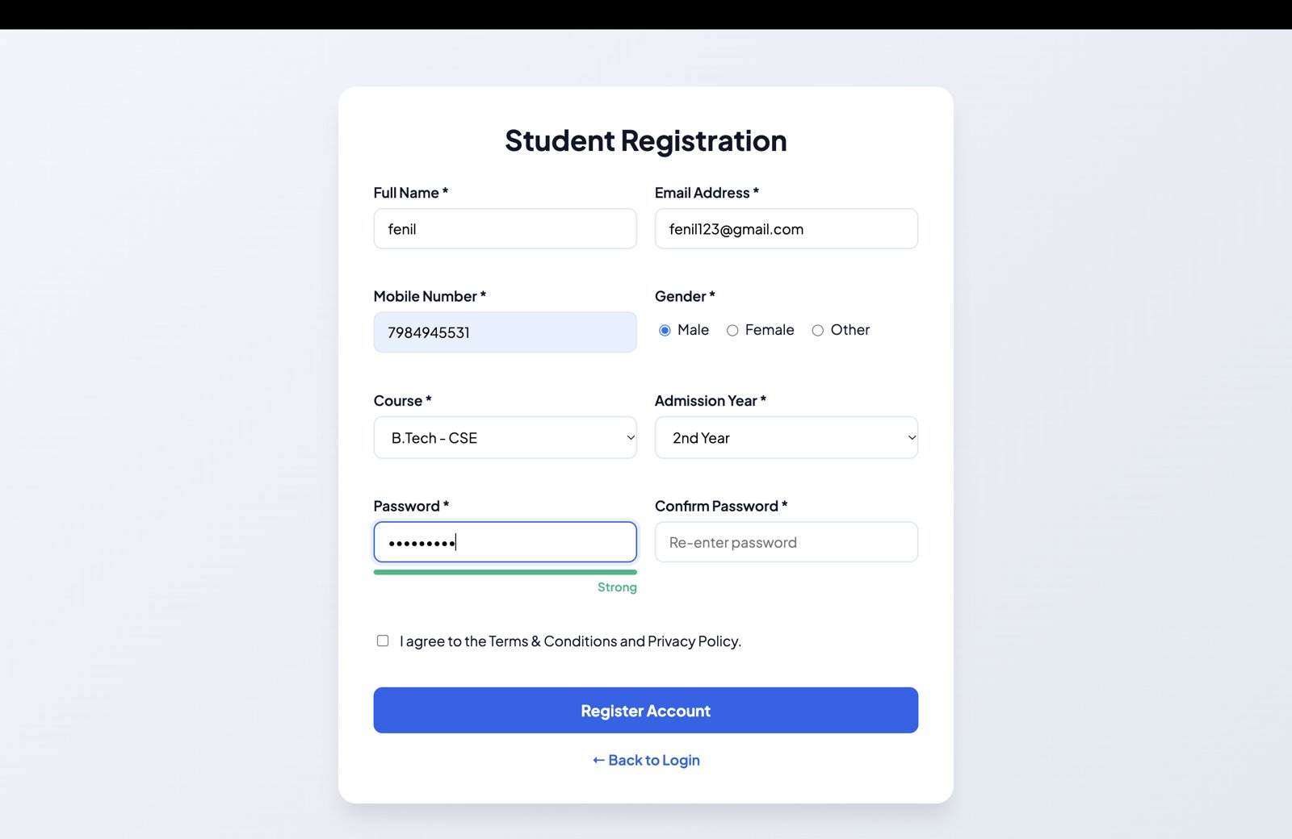
Figure 7: Strong password

6. Terms & Conditions Not Accepted
If the Terms & Conditions checkbox is not ticked, the form cannot be submitted and an error message is shown below the checkbox.
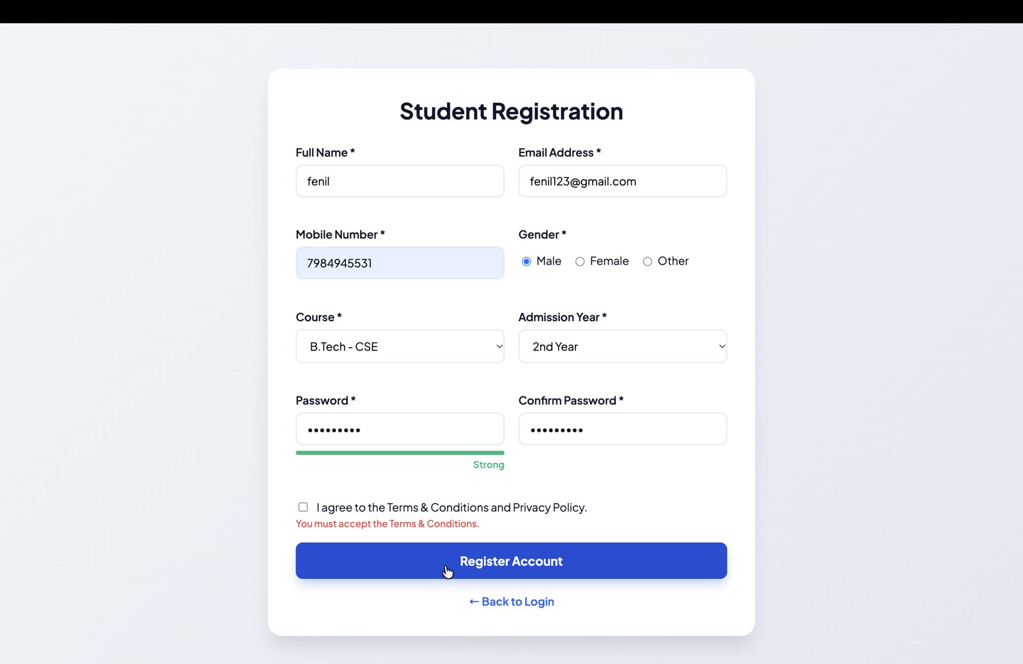
Figure 8: "You must accept the Terms & Conditions." error

